**SMART Targets**

* Show how 25 data sets of data can be processed in under 2 hours?

This target has been shown and referenced in my report by showing how many processors that would be required to reach the target of sub 2-hour processing time.

* Simultaneous programs can be run whilst processing the data?

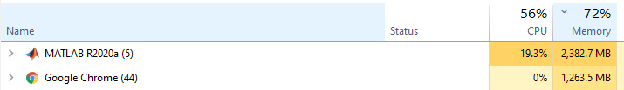

As shown in the image above we can see that MATLAB, for me, takes 19% of the cpu and about 2.4GB worth of ram which if we scale up, would be easily manageable with the correct hardware to run simultaneous programmes whilst processing the data.

* The code will be written in MATLAB with correctly labelled folders and sub-folders?

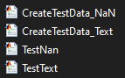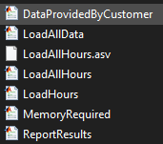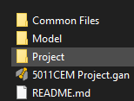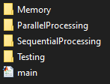

From the images show we can see that all files, folders and sub-folders are named to what their purpose is.

* The code will run automatically from starting of code and require no manual input?

The code successfully runs without any manual input required.

* All requirements to run code will be contained in the same folder with no irrelevant files/folders?

All files/folders required to run the code is all contained in the 5011CEM2021_dhaliw38 folder.